* Project Life Cycle Approach to Scheduling

There are many different planning or scheduling methodologies for project management. In the 20+ years of using technologies that support scheduling, planning and resource demand and capacity planning, we the authors have experienced and heard that Project is not a good tool for certain types of lifecycle planning.

This is clearly untrue. If you think about what scheduling technologies are, they are simply relational databases. It is the approach of how you setup, layout or build a schedule or project plan that makes it better or worse.

Yes some tools have pre-built views, reports or are tended to be used in certain industries (like construction), but that has been a product of the history or length of these technologies and the need for that type of tool. For example it really has only been in the last 20 years that IT or system or software development has really exploded. In comparison engineering or construction projects have been ongoing for centuries.

What we hope you learn from this section is that it is up to you and how you would like to organize, view, track, report and manage a schedule that determines it’s ability to support you in the Project Lifecycle that you are using.

Remember MS Project is a relational database, just like almost every other scheduling tools (some are just flat files, like Excel), but for our discussion today, we are only considering true scheduling technologies.

Where MS Project has grown and overshadowed every other scheduling tool out there by volume of purchases, is the simplicity, flexibility and ease of use that the tool provides to its user.

With a little thought you can make Project behave and support any lifecycle methodology approach to scheduling. Whether Scrum, SDLC, Lean, Waterfall, etc. you have the same functional components for managing a project. Namely the following:

* Fields (native and custom)
* Sorting Capabilities
* Grouping
* Filtering
* Views & Reports

Remember, demand, work, deliverables, tasks, activities are all the same object. A task is a row that has data and meta-data associated to it. That means you can have a column for your task that identifies it’s properties. For example a task about “rollout training for end users” can be organized by phase, type of work (training), by department who will deliver it, even by the skillset needed.

As you will see in the next few sections, you can take that activity or task and organize it any way you like, it still represents demand, work or something that has a typical time-phased activity that needs to be scheduled.

We hope you open your mind and think about using Project in many different lifecycle planning and managing approaches and find the combination that works best for you and the projects that you are managing.

* *WBS Scheduling Approach*

The concept behind Work Breakdown Structure (WBS) scheduling is to arrange work packages or work elements (tasks) into a grouping of activities that have a common element to them. For example, documentation tasks may occur across the entire project, but are grouped, estimated and planned and in many cases invoiced in common location within the schedule.

Work Breakdown Structure (WBS) is a tool / methodology that defines a project grouping of a project’s discrete work elements (tasks) in a way that helps organize define the total work scope of the project.

In using a WBS to define a project schedule, (a project schedule is the series of activities (time-phased or calendar based) that links the tasks to be done with the resources that will do that work, the project manager must have a work breakdown structure (WBS) and estimates. The project schedule is part of the project plan (not the whole plan, but an artifact of the project plan).

A great value that a WBS creates is it allows you to organized and decompose a larger set of tasks into smaller subset of related activities. Remember that this is an exercise that isn’t about sequencing, but more focused on establishing tasks and estimates

The advantage of using a WBS is that you can quickly get to a proper level of detail (the proper level will be dependent upon the needs / culture of the Project Manager, the Organization or the work being planned.

A common misunderstanding is that a project schedule has to stay lined out or organized in this manner. While it may be easier to see organized types of work, it becomes more difficult to manage the related work activities.

Remember that Project is a relational database and we can group tasks quickly and efficiently based upon simple common fields or values within the project tasks (i.e. a custom column).

Key Benefits of WBS Scheduling

* Organizing Key Activities, Deliverables by Functionality or Activity Type
* Excellent approach to working with a team to map out key work activities
* Break out Larger work deliverables into manageable and assignable work
* Easy to see all like work grouped or in a localized area
* Fast References to work that can be collapsed by section
* Typically aligned with a BOM or SOW/Contract deliverables for billing

In Project, you may require that your WBS be related to Accounting or Other Tracking Systems. If your project would benefit from having detailed WBS codes that are made up of specific lengths, sequences, or sets of numbers and letters, you can define a single custom WBS code mask (code mask: The format that you define for a work breakdown structure (WBS) code or a custom outline code. The mask specifies the sequence and number of letters or numbers required for each level and the symbol separating the levels.) for the project. (No project can have more than a single custom code mask.) The custom WBS code is recorded in the WBS field.

As with outline numbers, each level of a custom WBS code represents an outline level (outline level: The number of levels that a task is indented from the top level of the outline. You can indent tasks up to 65,000 levels in Project.) in the task list. You can use a unique format for each level of the code, and each level is listed in the code according to the hierarchy of tasks, summary tasks, and subtasks.

So clearly you have room to grow, organize your project schedule.

Below is an example of a Project Schedule Organized in a Work Breakdown Structure format. The overall concept is that WBS is about work activities

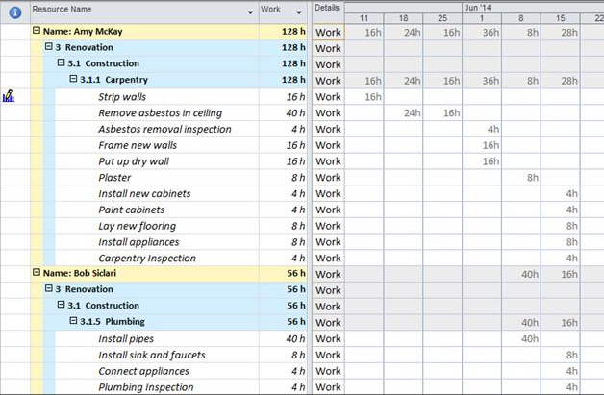

* *WBS Methodology Scheduling Approach*

We encourage you the reader to try using a WBS to help map out key deliverables and activities. What is wonderful about Project 2013 is that there are myriad of different tools you can plan and organize your project in and then simply by using the Rich Copy/Paste features and the manual scheduling, to drop that in and begin the estimating, linking and establishing a dynamic schedule. By leveraging the simplistic approach of a WBS, you can rapidly build a schedule, feel confident that you have not missed key planning tasks and activities and then sequence the work, establishing relationships between your dependent tasks.

* *Agile Methodology Scheduling Approach*

As mentioned above, Agile, Scrum or other Agile approaches to project scheduling take on a more iterative approach and feel.

A common misconception is that MS Project cannot handle this or isn’t designed for this. This is clearly not the case. Remember Project is a database and can be laid out to sort, group, filter and organize work into views based upon data at the task level.

In today’s ever growing IT or software development world, the work is in many times iterative, however that is not limited to just IT work. In engineering projects, in many cases there are series of design / builds (30%, 60% and 90%) cycles of work that touches or retouches pieces of project work.

What is nice about using iterative planning and scheduling approaches (Agile) is that you can break apart the work by features and activities relating to these feature sets that need completed.

Key Benefits of Agile Scheduling

* Highly Iterative and easily to clone sections that dynamically build off of each other
* Burn Down Charts, Views, Sprints and Groupings allow for Easy to follow Work Deliverables
* Manual Scheduling and Integration with other Scheduling Tools (Team Foundation Server)
* Provides a way for work to be broken up into iterative (Sprints) and aligned with key categories or summary activities (such as a Software Development Lifecycle (SDLC).

In the example below, we illustrate lining out the key features (un-named), but essentially the tasks that need to be managed based upon the Sprint, priority, customer need, etc.

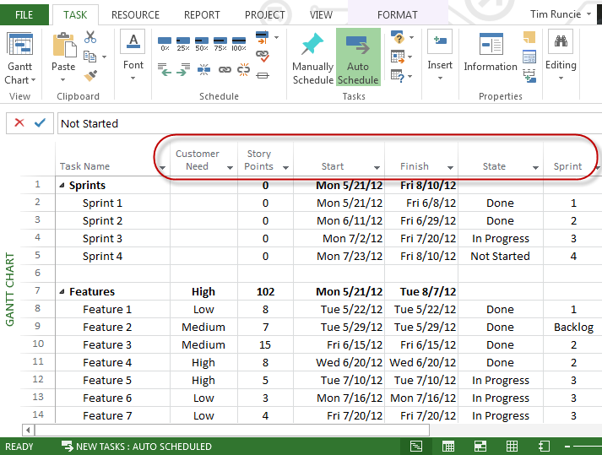

* *Agile Methodology Scheduling Approach*

In the next example, we use project’s fields that to group by a Burn Down view, showcasing features, sprints and key work that is being managed, by simply grouping by the state of the work (done, in progress, backlog, etc.).

Remember you can quickly and efficiently embed these as tables or views in project to quickly re-organized the schedule back into any manner of layout (WBS, Waterfall, etc.) desired.

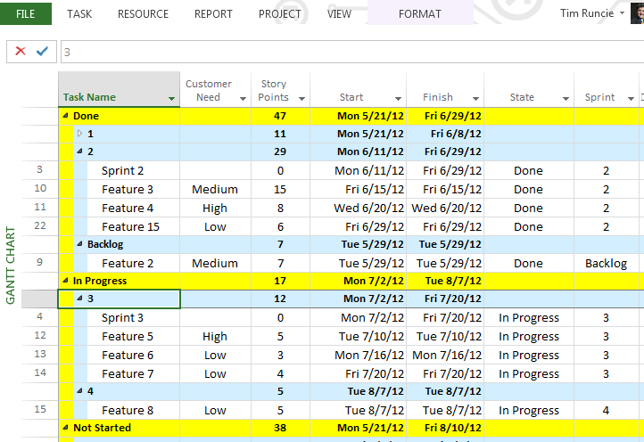

* *Agile Methodology Grouping*
* *Waterfall (Project Lifecycle by Phase) Scheduling Approach*

While we can write an entire chapter on just the Waterfall approach to planning and scheduling, we want to introduce the idea of waterfall planning activities that follow a lifecycle, phases, stages and time lapsed series of work activities.

This is very common in planning. Do note that in some portions of a project schedule, there are iterative or agile activities. These can be embedded and managed within on overall waterfall project schedule.

Waterfall scheduling methodology is a very popular version the systems development life cycle model for software development. The waterfall model defines a development method that is linear and sequential, with tasks following each other leading to a deliverable or a milestone for each phase of development. The overall concept that time phased work flows forward. Once a phase of development is completed, the development proceeds to the next phase and there it is not revisited.

The advantage of waterfall development is that it allows for work to be segmented and managed by functional groups, departments. A schedule can be set with deadlines for each stage of development and a product can proceed through the development process similar to an assembly line, and theoretically, be delivered on time. Development moves through phases, typically from concept, through design, implementation, testing, installation, troubleshooting, and ends up at operation and maintenance. In most waterfall planning, the phases of development proceed in strict order, without any overlapping or iterative steps.

The disadvantage of waterfall development is that it does not allow for much reflection or revision and if there are iterations that need to revisit or retouch work, the planning layout has to be handled differently. A good example is that once an application is in testing, it is very difficult to go back and change something that was not well-thought out in the concept stage. Other approaches or supplemental approaches to the waterfall methodology include joint application development (JAD), rapid application development (RAD),or sometimes JRAD, Joint Rapid Application Development, to update, fix and address product or solution defects.

Key Benefits of Waterfall Scheduling

* Easy to Organize and Visualize planning and managing of project work activities
* It can and is used for System or Software Development
* Works well for assigning large work to different groups to manage and hand off
* Lays out timeline planning for deliverable driven planning
* Project goes through distinct lifecycle, from requirements to design, implementation, testing and deployment

Below is an example of a Waterfall scheduling, also organized by a phased lifecycle. Remember that Waterfall in organizing tasks that traditionally have a path or predecessor / successor process and unfold linearly.

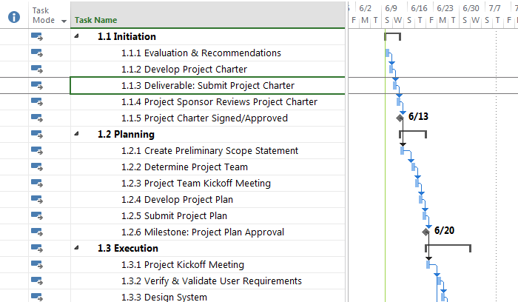

* *Waterfall Methodology Scheduling Approach*
* Key Points to Remember
* Project is capable of handling any scheduling methodology, not just traditional waterfall
* The ability to sort, group, filter creates a powerful solution for a project manager or scheduler looking to map demand (work) and integrate that with capacity (resource capability) planning
* Project 2013 has new reporting capabilities that give you efficient review of planning or actual work
* Regardless of your scheduling or methodology preference, using manual, or automatic scheduling gives control of the work planning to the end user. Leveraging a layout approach (Agile, Waterfall, SDLC, WBS, etc.) is up to the end user how they want to sort, group or view the information